INTRODUCTION: -

Many fast Shop Management system items have flooded the markets but computer, printer have emerged as the most popular item as it is cheaper, very easy to buy and parts. Urban and semi-urban markets are controlled by computer parts and other component are Top Ramen and other brands.

OBJECTIVE: -

The primary objective of the model report is to facilitate the entrepreneurs in
Understanding the importance of setting up unit of Ready to Desktop, laptop, printer technology and financial parameters of various components for preparation and submission of project proposal to bank for sanction of long term loan. This model report will serve as guidance to the entrepreneurs on starting up
such a new project and basic technical knowledge for setting up such a facility

SCREEN SHOTS

Login Page

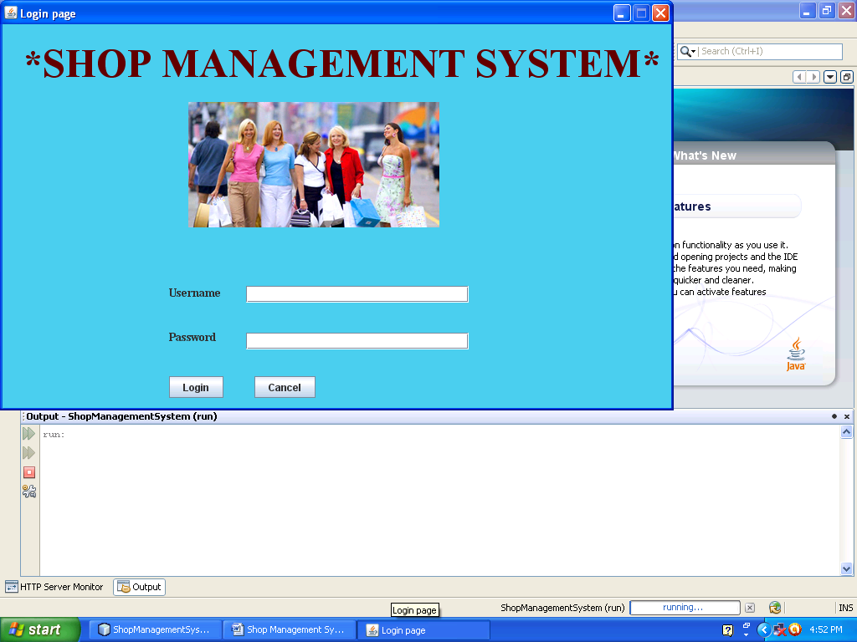

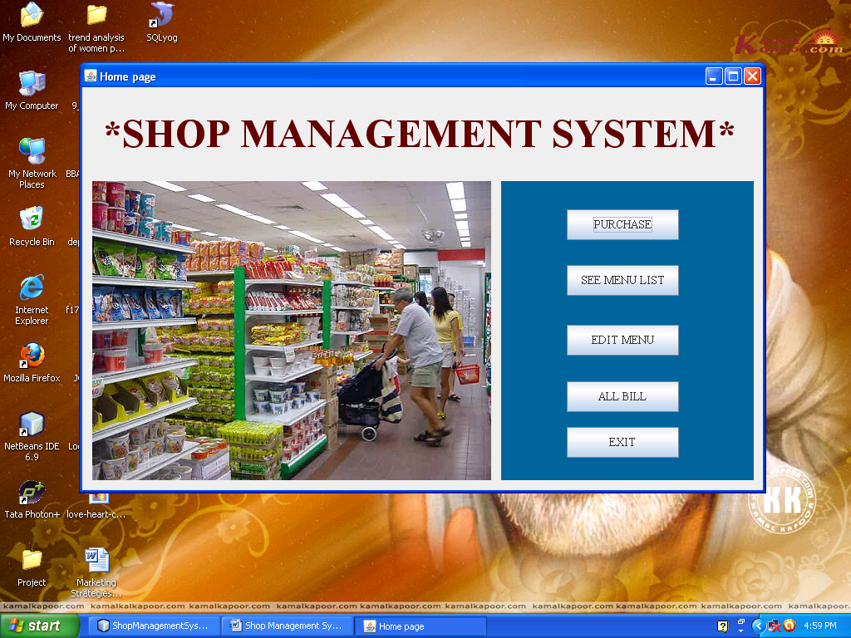
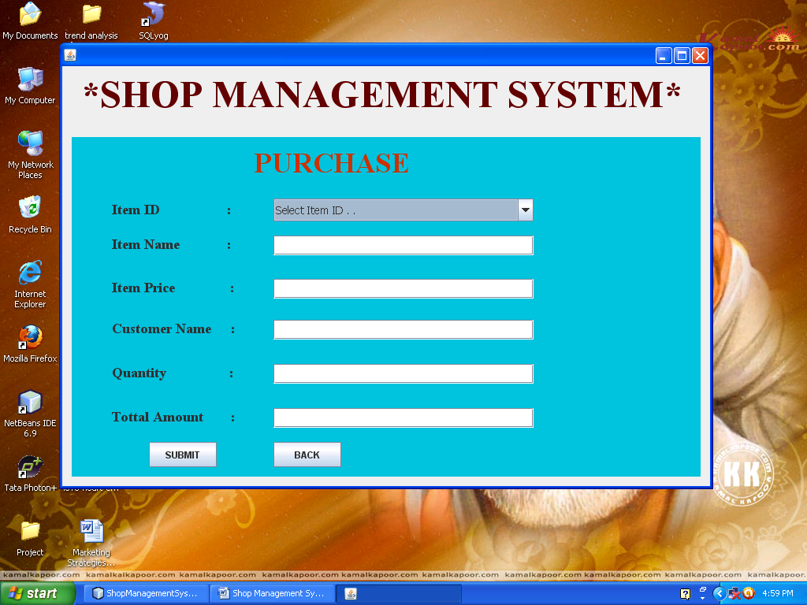

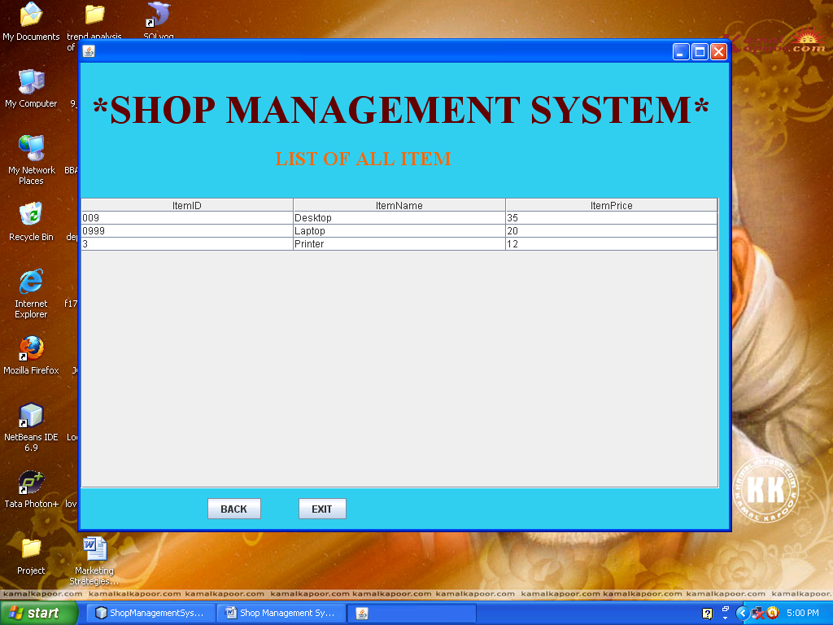

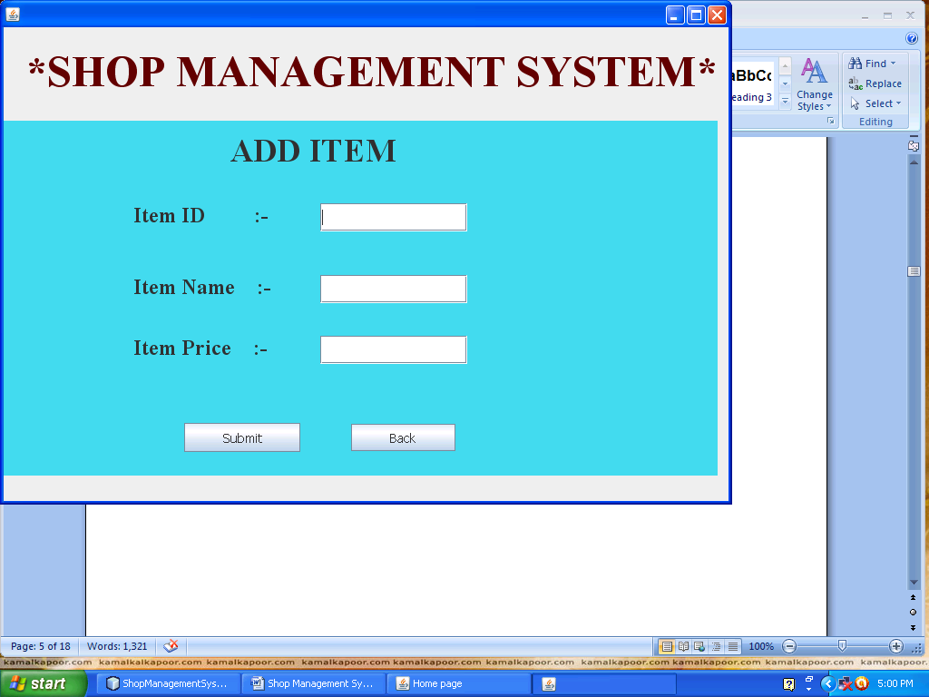

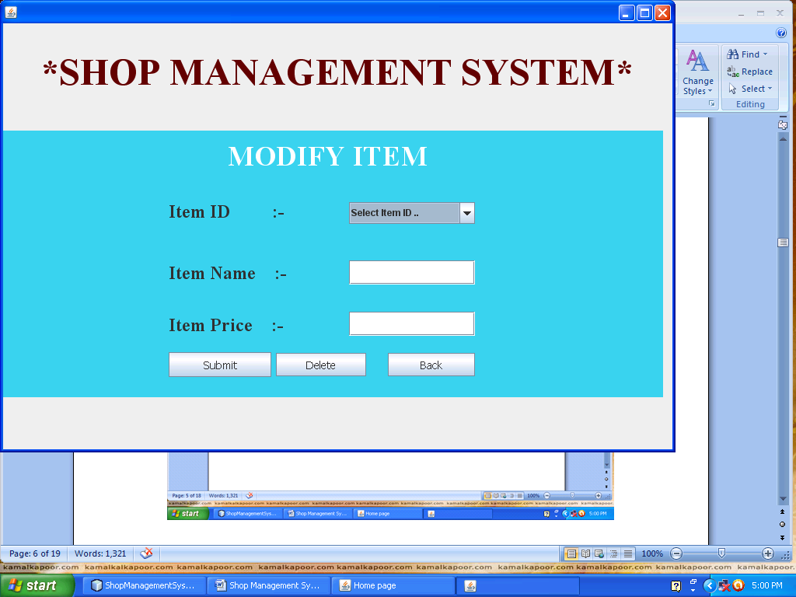

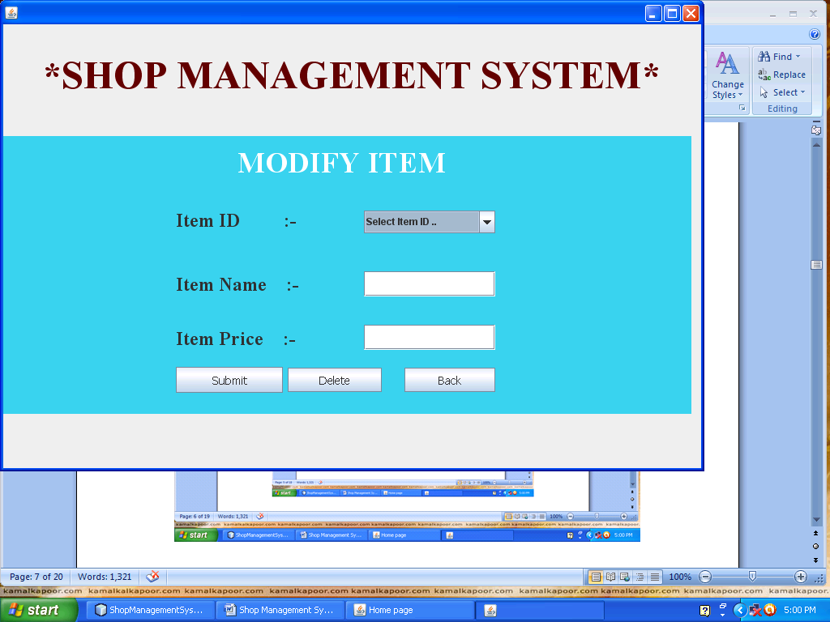
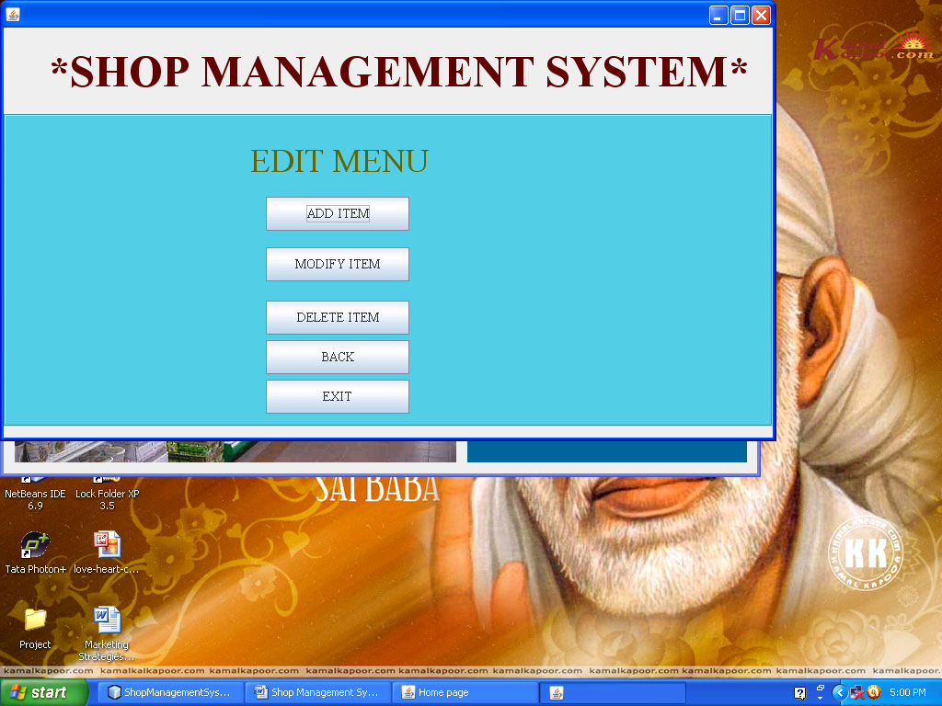
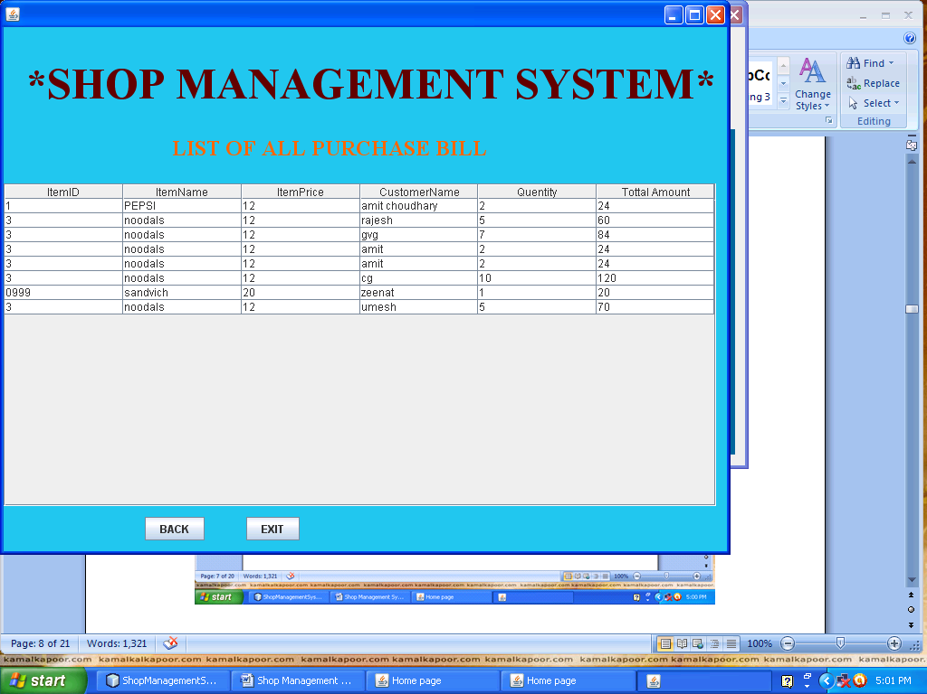

CODING OF THE PROJECT

Loginpage.java

private void jButton1ActionPerformed(java.awt.event.ActionEvent evt) {
String username = txtusername.getText();
String password = txtpassword.getText();
if(username.equals("")){
JOptionPane.showMessageDialog(null, "Please enter your user name!");
txtusername.requestFocusInWindow();
return;
}
if(password.equals("")){
JOptionPane.showMessageDialog(null, "Please enter your password!");
txtpassword.requestFocusInWindow();
return;
}
if(username.equals("admin") && password.equals("admin"))
{
home obj = new home();
obj.setVisible(true);
this.dispose();
}// TODO add your handling code here:
else
{
JOptionPane.showMessageDialog(null, "Your user id or password is wrong");
txtusername.requestFocusInWindow();
}
}

Home page

private void jButton3ActionPerformed(java.awt.event.ActionEvent evt) {
Edit obj = new Edit();
obj.setVisible(true);// TODO add your handling code here:
}

private void jButton1ActionPerformed(java.awt.event.ActionEvent evt) {
purchase obj = new purchase();
obj.setVisible(true);
this.dispose();
}

private void jButton2ActionPerformed(java.awt.event.ActionEvent evt) {
try
{
AllItemList obj1 = new AllItemList();
obj1.setVisible(true);
this.dispose();
}
catch(Exception e)
{
e.printStackTrace();
}

}

private void jButton4ActionPerformed(java.awt.event.ActionEvent evt) {
try
{
AllPurchaseBill obj = new AllPurchaseBill();
obj.setVisible(true);// TODO add your handling code here:
this.dispose();
}
catch(Exception e)
{
e.printStackTrace();
}
}

ADD ITEM

private void jButton14ActionPerformed(java.awt.event.ActionEvent evt) {
Edit obj = new Edit();
obj.setVisible(true);// TODO add your handling code here:
this.dispose();
}

private void jButton13ActionPerformed(java.awt.event.ActionEvent evt) {
String id = txtitemid.getText();
String name = txtitemname.getText();
String price = txtitemprice.getText();
if(id.equals("")){
JOptionPane.showMessageDialog(null, "Please enter product id!");
txtitemid.requestFocusInWindow();
return;
}
if(name.equals("")){
JOptionPane.showMessageDialog(null, "Please enter product name!");
txtitemname.requestFocusInWindow();
return;
}
if(price.equals("")){
JOptionPane.showMessageDialog(null, "Please enter product price!");
txtitemprice.requestFocusInWindow();
return;
}
try
{
Class.forName("java.sql.Driver");
Connection con = DriverManager.getConnection("jdbc:mysql://localhost:3306/fastfood", "root", "root");
PreparedStatement ps = con.prepareStatement("insert into item values(?,?,?)");
ps.setString(1, id);
ps.setString(2, name);
ps.setString(3, price);
int i = ps.executeUpdate();
if(i>0)
{
JOptionPane.showMessageDialog(null, "Item inserted successfully!");
txtitemid.setText("");
txtitemname.setText("");
txtitemprice.setText("");
txtitemid.requestFocusInWindow();
}
else{
JOptionPane.showMessageDialog(null, "Item not inserted successfuly!");
}
}
catch(Exception ex)
{
JOptionPane.showMessageDialog(null, ex);
}
}

ALL item list
public class AllItemList extends javax.swing.JFrame {
private Vector<Vector<String>> data;
private Vector<String> header;

/** Creates new form AllItemList */

public AllItemList() throws Exception{
DBEngine dbengine = new DBEngine();
data = dbengine.getEmployee();
header = new Vector<String>();
header.add("ItemID");
header.add("ItemName");
header.add("ItemPrice");
initComponents();
}

private void formWindowOpened(java.awt.event.WindowEvent evt) {
// TODO add your handling code here:
}

private void jButton2ActionPerformed(java.awt.event.ActionEvent evt) {
this.dispose(); // TODO add your handling code here:
}

private void jButton1ActionPerformed(java.awt.event.ActionEvent evt) {
home obj = new home();
obj.setVisible(true);
this.dispose();// TODO add your handling code here:
}
public static void main(String args[]) {
java.awt.EventQueue.invokeLater(new Runnable() {
public void run() {
try
{
new AllItemList().setVisible(true);
}
catch(Exception e)
{
e.printStackTrace();
}
}
});
}

ALL PURCHASE PROCUCT

public class AllPurchaseBill extends javax.swing.JFrame {
private Vector<Vector<String>> data;
private Vector<String> header;
/** Creates new form AllPurchaseBill */
public AllPurchaseBill() throws Exception{
data = getEmployee();
header = new Vector<String>();
header.add("ItemID");
header.add("ItemName");
header.add("ItemPrice");
header.add("CustomerName");
header.add("Quentity");
header.add("Tottal Amount");
initComponents();
}
private void jButton1ActionPerformed(java.awt.event.ActionEvent evt) {
home obj = new home();
obj.setVisible(true);
this.dispose();// TODO add your handling code here:
}

private void jButton2ActionPerformed(java.awt.event.ActionEvent evt) {
this.dispose(); // TODO add your handling code here:
}

/**
* @param args the command line arguments
*/
public Vector getEmployee()throws Exception
{
Vector<Vector<String>> employeeVector = new Vector<Vector<String>>();

Class.forName("java.sql.Driver");
Connection con = DriverManager.getConnection("jdbc:mysql://localhost:3306/fastfood", "root", "root");
PreparedStatement pre = con.prepareStatement("select * from purchase ");
ResultSet rs = pre.executeQuery();

while(rs.next())
{
Vector<String> employee = new Vector<String>();
employee.add(rs.getString(1)); //Empid
employee.add(rs.getString(2)); //name
employee.add(rs.getString(3)); //position
employee.add(rs.getString(4));
employee.add(rs.getString(5));
employee.add(rs.getString(6));
//employee.add(rs.getString(4)); //department
employeeVector.add(employee);
}

/*Close the connection after use (MUST)*/

return employeeVector;
}
public static void main(String args[]) {
java.awt.EventQueue.invokeLater(new Runnable() {
public void run() {
try
{
new AllPurchaseBill().setVisible(true);
}
catch(Exception e)
{
e.printStackTrace();
}
}
});
}

EDIT

private void jButton5ActionPerformed(java.awt.event.ActionEvent evt) {
this.dispose(); // TODO add your handling code here:
}

private void jButton4ActionPerformed(java.awt.event.ActionEvent evt) {
home obj = new home();
obj.setVisible(true);// TODO add your handling code here:
this.dispose();
}

private void jButton1ActionPerformed(java.awt.event.ActionEvent evt) {
AddItem obj = new AddItem();
obj.setVisible(true);
this.dispose();
}

private void jButton2ActionPerformed(java.awt.event.ActionEvent evt) {
ModifyItem obj = new ModifyItem();
obj.setVisible(true);
this.dispose();
}

private void jButton3ActionPerformed(java.awt.event.ActionEvent evt) {
ModifyItem obj = new ModifyItem();
obj.setVisible(true);
this.dispose(); // TODO add your handling code here:
}

Edit

private void jButton13ActionPerformed(java.awt.event.ActionEvent evt) {
String itemid = comitemid.getSelectedItem().toString();
String name = txtname.getText();
String price = txtprice.getText();

if(name.equals("")){
JOptionPane.showMessageDialog(null, "Please enter product name!");
txtname.requestFocusInWindow();
return;
}
if(price.equals("")){
JOptionPane.showMessageDialog(null, "Please enter product price!");
txtprice.requestFocusInWindow();
return;
}
try {

Class.forName("java.sql.Driver");
Connection con = DriverManager.getConnection("jdbc:mysql://localhost:3306/fastfood", "root", "root");
PreparedStatement ps = con.prepareStatement("update item set ItemName = '"+name+"', ItemPrice = '"+price+"' where ItemID = '"+itemid+"'");
int i = ps.executeUpdate();
if(i>0) {
JOptionPane.showMessageDialog(null, "ITEM UPDATED SUCCESSFULLY!");

txtname.setText("");
txtprice.setText("");
comitemid.requestFocusInWindow();
} else{
JOptionPane.showMessageDialog(null, "ITEM NOT UPDATED SUCCESSFULLY!");
}
} catch(Exception ex) {
JOptionPane.showMessageDialog(null, ex);
}
}

private void jButton14ActionPerformed(java.awt.event.ActionEvent evt) {
Edit obj = new Edit();
obj.setVisible(true);// TODO add your handling code here:
this.dispose();
}

private void formWindowOpened(java.awt.event.WindowEvent evt) {
try
{
Class.forName("java.sql.Driver");
Connection con = DriverManager.getConnection("jdbc:mysql://localhost:3306/fastfood", "root", "root");
PreparedStatement ps = con.prepareStatement("select * from item");
ResultSet rs = ps.executeQuery();
while(rs.next())
{
comitemid.addItem(rs.getString(1));
}
}
catch(Exception ex)
{
JOptionPane.showMessageDialog(null, ex);
}
}

private void comitemidItemStateChanged(java.awt.event.ItemEvent evt) {
try
{
String itemid = comitemid.getSelectedItem().toString();
Class.forName("java.sql.Driver");
Connection con = DriverManager.getConnection("jdbc:mysql://localhost:3306/fastfood", "root", "root");
PreparedStatement ps = con.prepareStatement("select * from item where Itemid = '"+itemid+"'");
ResultSet rs = ps.executeQuery();
if(rs.next())
{
txtname.setText(rs.getString(2));
txtprice.setText(rs.getString(3));
}
}
catch(Exception ex)
{
JOptionPane.showMessageDialog(null, ex);
}
}

private void jButton15ActionPerformed(java.awt.event.ActionEvent evt) {
try
{
String itemid = comitemid.getSelectedItem().toString();
Class.forName("java.sql.Driver");
Connection con = DriverManager.getConnection("jdbc:mysql://localhost:3306/fastfood", "root", "root");
PreparedStatement ps = con.prepareStatement("delete from item where Itemid = '"+itemid+"'");
int i = ps.executeUpdate();
if(i>0) {
JOptionPane.showMessageDialog(null, "ITEM DELETED SUCCESSFULLY!");

txtname.setText("");
txtprice.setText("");
comitemid.requestFocusInWindow();
} else{
JOptionPane.showMessageDialog(null, "ITEM NOT DELETED SUCCESSFULLY!");
}
}
catch(Exception ex)
{
JOptionPane.showMessageDialog(null, ex);
}
}

Purch

private void jButton2ActionPerformed(java.awt.event.ActionEvent evt) {
home obj = new home();
obj.setVisible(true);// TODO add your handling code here:
this.dispose();
}

private void formWindowOpened(java.awt.event.WindowEvent evt) {
try
{
Class.forName("java.sql.Driver");
Connection con = DriverManager.getConnection("jdbc:mysql://localhost:3306/fastfood", "root", "root");
PreparedStatement ps = con.prepareStatement("select * from item");
ResultSet rs = ps.executeQuery();
while(rs.next())
{
comitemid.addItem(rs.getString(1));
}
}
catch(Exception ex)
{
JOptionPane.showMessageDialog(null, ex);
} // TODO add your handling code here:
}

private void comitemidItemStateChanged(java.awt.event.ItemEvent evt) {
try
{
String itemid = comitemid.getSelectedItem().toString();
Class.forName("java.sql.Driver");
Connection con = DriverManager.getConnection("jdbc:mysql://localhost:3306/fastfood", "root", "root");
PreparedStatement ps = con.prepareStatement("select * from item where Itemid = '"+itemid+"'");
ResultSet rs = ps.executeQuery();
if(rs.next())
{
txtname.setText(rs.getString(2));
txtprice.setText(rs.getString(3));
txtcustname.requestFocusInWindow();
}
}
catch(Exception ex)
{
JOptionPane.showMessageDialog(null, ex);
}
}

private void txtquantityActionPerformed(java.awt.event.ActionEvent evt) {
float price = Float.parseFloat(txtprice.getText());
float quantity = Float.parseFloat(txtquantity.getText());
float tottalamount = price * quantity;
txttottalamount.setText(Float.toString(tottalamount));

}

private void jButton1ActionPerformed(java.awt.event.ActionEvent evt) {
String id = comitemid.getSelectedItem().toString();
String itemname = txtname.getText();
float price = Float.parseFloat(txtprice.getText());
String custname = txtcustname.getText();
float quantity = Float.parseFloat(txtquantity.getText());
float amount = Float.parseFloat(txttottalamount.getText());
try
{

Class.forName("java.sql.Driver");
Connection con = DriverManager.getConnection("jdbc:mysql://localhost:3306/fastfood", "root", "root");
PreparedStatement ps = con.prepareStatement("insert into purchase values(?,?,?,?,?,?)");
ps.setString(1, id);
ps.setString(2, itemname);
ps.setFloat(3, price);
ps.setString(4, custname);
ps.setFloat(5, quantity);
ps.setFloat(6, amount);
int i = ps.executeUpdate();
if(i>0)
{
JOptionPane.showMessageDialog(null, "Your purchase order submited successfully!");
comitemid.setSelectedItem("select Item ID ..");
txtname.setText("");
txtprice.setText("");
txtcustname.setText("");
txtquantity.setText("");
txttottalamount.setText("");
//txtitemprice.setText("");
comitemid.requestFocusInWindow();
}
else{
JOptionPane.showMessageDialog(null, "Item not inserted successfuly!");
}
}
catch(Exception ex)
{
JOptionPane.showMessageDialog(null, ex);
} }

Connectivity
public Vector getEmployee()throws Exception
{
Vector<Vector<String>> employeeVector = new Vector<Vector<String>>();

Class.forName("java.sql.Driver");
Connection con = DriverManager.getConnection("jdbc:mysql://localhost:3306/fastfood", "root", "root");
PreparedStatement pre = con.prepareStatement("select * from item ");
ResultSet rs = pre.executeQuery();

while(rs.next())
{
Vector<String> employee = new Vector<String>();
employee.add(rs.getString(1)); //Empid
employee.add(rs.getString(2)); //name
employee.add(rs.getString(3)); //position
//employee.add(rs.getString(4)); //department
employeeVector.add(employee);
}

/*Close the connection after use (MUST)*/

return employeeVector;
}
}

MYSQL QUERY

create database fastfood;
USE `fastfood`;
SET @OLD_SQL_MODE=@@SQL_MODE, SQL_MODE='NO_AUTO_VALUE_ON_ZERO';

/*Table structure for table `item` */

DROP TABLE IF EXISTS `item`;

CREATE TABLE `item` (
`ItemID` varchar(20) NOT NULL,
`ItemName` varchar(100) default NULL,
`ItemPrice` float default NULL,
PRIMARY KEY (`ItemID`)
) ENGINE=InnoDB DEFAULT CHARSET=latin1;

/*Data for the table `item` */

insert into `item` (`ItemID`,`ItemName`,`ItemPrice`) values ('009','slice',35);
insert into `item` (`ItemID`,`ItemName`,`ItemPrice`) values ('0999','sandvich',20);
insert into `item` (`ItemID`,`ItemName`,`ItemPrice`) values ('3','noodals',12);

/*Table structure for table `purchase` */

DROP TABLE IF EXISTS `purchase`;

CREATE TABLE `purchase` (
`ItemID` varchar(100) NOT NULL,
`ItemName` varchar(200) default NULL,
`ItemPrice` float default NULL,
`CustName` varchar(300) default NULL,
`Quantity` float default NULL,
`amount` float default NULL
) ENGINE=InnoDB DEFAULT CHARSET=latin1;

/*Data for the table `purchase` */

insert into `purchase` (`ItemID`,`ItemName`,`ItemPrice`,`CustName`,`Quantity`,`amount`) values ('1','PEPSI',12,'amit choudhary',2,24);
insert into `purchase` (`ItemID`,`ItemName`,`ItemPrice`,`CustName`,`Quantity`,`amount`) values ('3','noodals',12,'rajesh',5,60);
insert into `purchase` (`ItemID`,`ItemName`,`ItemPrice`,`CustName`,`Quantity`,`amount`) values ('3','noodals',12,'gvg',7,84);
insert into `purchase` (`ItemID`,`ItemName`,`ItemPrice`,`CustName`,`Quantity`,`amount`) values ('3','noodals',12,'amit',2,24);
insert into `purchase` (`ItemID`,`ItemName`,`ItemPrice`,`CustName`,`Quantity`,`amount`) values ('3','noodals',12,'amit',2,24);
insert into `purchase` (`ItemID`,`ItemName`,`ItemPrice`,`CustName`,`Quantity`,`amount`) values ('3','noodals',12,'cg',10,120);
insert into `purchase` (`ItemID`,`ItemName`,`ItemPrice`,`CustName`,`Quantity`,`amount`) values ('0999','sandvich',20,'zeenat',1,20);

SET SQL_MODE=@OLD_SQL_MODE;

